DIRSEARCH TOOL – COMPREHENSIVE TECHNICAL DOCUMENTATION
An Advanced Web Directory and File Enumeration Tool for Ethical Hacking & Penetration Testing

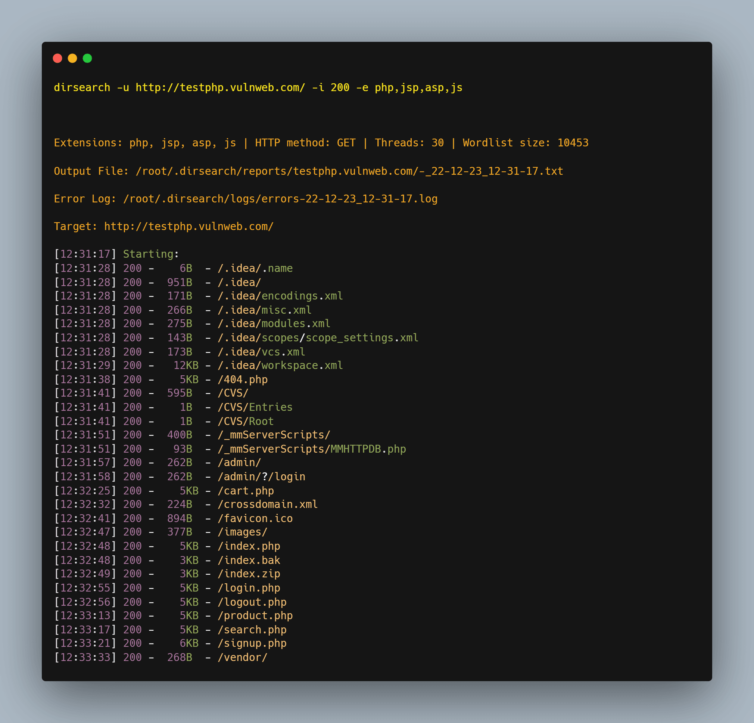
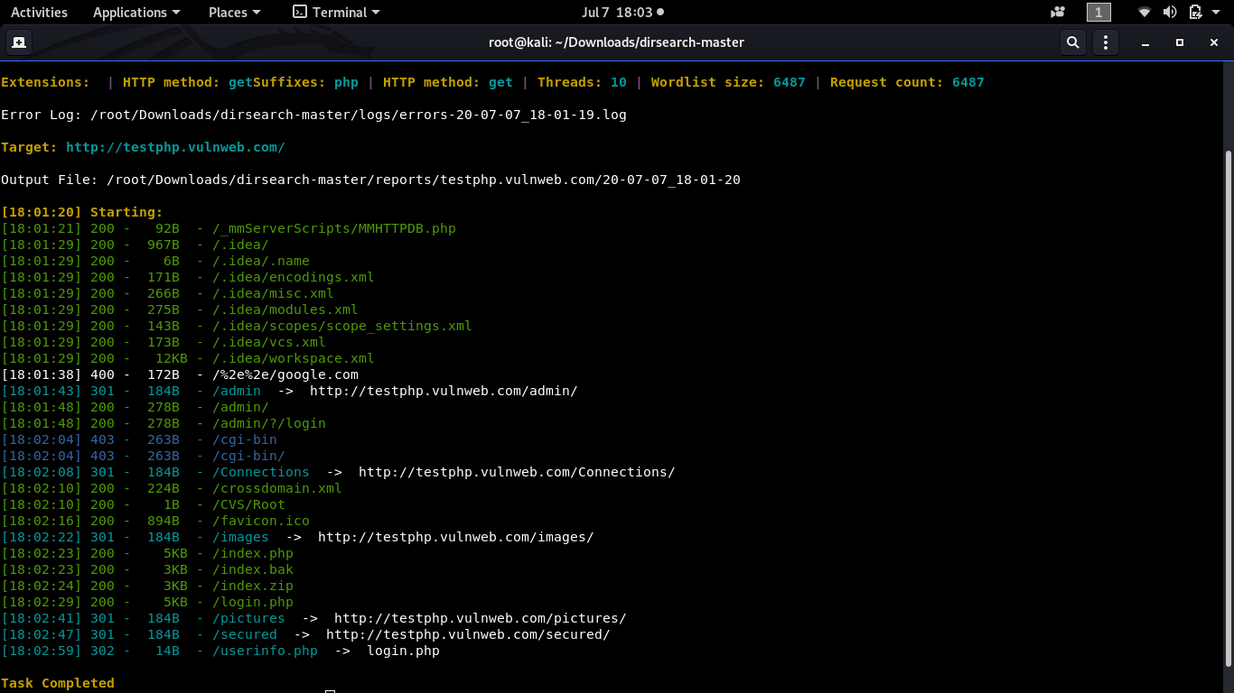

ABSTRACT
Web applications often contain hidden directories, files, and endpoints that are not intended to be publicly accessible. These resources may expose sensitive data, configuration files, administrative interfaces, or vulnerable application logic. This document presents a comprehensive technical study of Dirsearch, an advanced web directory and file enumeration tool widely used in ethical hacking and penetration testing. The report explains the theoretical background, internal working mechanism, command usage, practical case studies, advantages, limitations, and defensive considerations. The objective of this documentation is to provide an academic and practical understanding of Dirsearch suitable for cybersecurity coursework, lab records, interviews, and professional security assessments.

1. INTRODUCTION
Modern web applications are complex systems composed of multiple components such as APIs, admin panels, backup directories, and development endpoints. Many of these components are not linked directly from the main website but remain accessible if their paths are known.
Attackers commonly exploit this situation by performing directory and file enumeration, a technique that systematically tests common paths on a web server to discover hidden resources.
Dirsearch is a powerful enumeration tool developed to automate this process with high efficiency. It improves upon older tools by supporting recursive scanning, multiple extensions, HTTP methods, and smart response handling.

2. OBJECTIVE OF THE STUDY
The objectives of this documentation are:
- To understand web directory and file enumeration techniques
- To study the working mechanism of Dirsearch
- To analyze Dirsearch command usage and options
- To demonstrate real-world usage through practical case studies
- To evaluate strengths, limitations, and security implications
- To provide exam-ready and submission-ready content

3. BACKGROUND: WEB DIRECTORY ENUMERATION IN CYBER SECURITY
Web directory enumeration is part of the Scanning & Enumeration phase of penetration testing. It focuses on identifying:
- Hidden directories and files
- Backup and configuration files
- Administrative panels
- API endpoints and development resources
Because web servers respond differently to valid and invalid requests, attackers can infer the existence of resources even if directory listing is disabled.
Dirsearch automates this discovery process using optimized brute-force techniques.

4. OVERVIEW OF DIRSEARCH TOOL
Dirsearch is an open-source web content scanner written in Python. It is included in Kali Linux and is also widely used in bug bounty programs and real-world penetration tests.
Key features of Dirsearch include:
- Recursive directory scanning
- Support for multiple file extensions
- HTTP method customization
- Intelligent filtering of false positives
Dirsearch focuses solely on resource discovery and does not exploit vulnerabilities directly.

5. ARCHITECTURE AND WORKING MECHANISM

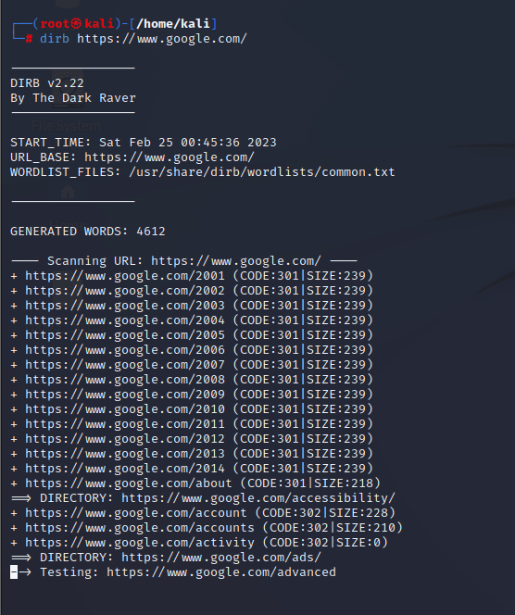
Dirsearch follows a structured enumeration workflow:
- Target URL Input
The base URL of the web application is provided.
- Wordlist Loading
A comprehensive wordlist of directory and file names is loaded.
- Request Generation
HTTP requests are generated using specified methods (GET, HEAD, etc.).
- Response Evaluation
HTTP status codes, content length, and response patterns are analyzed.
- Recursive Enumeration
Discovered directories are scanned further for nested content.
- Result Reporting
Valid directories and files are displayed and optionally saved.
This layered approach makes Dirsearch more thorough than basic tools.

6. INSTALLATION AND ENVIRONMENT
Dirsearch is pre-installed in Kali Linux.
To verify installation:
dirsearch --help
Dirsearch requires Python and works with both HTTP and HTTPS targets.

7. COMMAND USAGE AND ANALYSIS
7.1 Basic Directory Enumeration
dirsearch -u http://example.com
Uses default settings to discover directories and files.

7.2 Specify File Extensions
dirsearch -u http://example.com -e php,html,js,txt
Enumerates files with specific extensions.

7.3 Recursive Scanning
dirsearch -u http://example.com -r
Automatically scans discovered directories.

7.4 Exclude Status Codes
dirsearch -u http://example.com --exclude-status=403,404
Reduces noise from restricted or missing pages.

7.5 Save Output to File
dirsearch -u http://example.com -o dirsearch_results.txt
Stores results for reporting.

8. PRACTICAL CASE STUDY
Scenario
A penetration tester performs web enumeration on a target application.
Execution
dirsearch -u http://192.168.146.131 -e php,html -r
Observations
- Discovered /admin/ directory
- Found /config.php file
- Identified /api/v1/ endpoint
Impact Analysis
These findings exposed sensitive application functionality and configuration details, enabling further attacks such as authentication bypass and information disclosure.

9. ADVANTAGES OF DIRSEARCH
- Recursive scanning capability
- Supports multiple file extensions
- Intelligent filtering of responses
- More thorough than basic brute-force tools
- Suitable for labs, CTFs, and real-world pentests

10. LIMITATIONS OF DIRSEARCH
- Slower than Gobuster in some cases
- Generates noticeable traffic
- Dependent on wordlists
- Requires tuning to avoid false positives

11. DIRSEARCH VS OTHER WEB ENUMERATION TOOLS
Tool | Speed | Depth | Best Use Case
Dirsearch | Medium–High | High | Deep web enumeration
Gobuster | High | Medium | Fast discovery
DIRB | Medium | Low | Learning & basics
Feroxbuster | High | Very High | Large-scale enumeration
Dirsearch is best suited for thorough and recursive enumeration.

12. SECURITY AND DEFENSIVE CONSIDERATIONS
Organizations can defend against Dirsearch-style attacks by:
- Removing unused files and directories
- Implementing rate limiting
- Deploying Web Application Firewalls (WAF)
- Enforcing authentication on sensitive paths

13. LEGAL AND ETHICAL CONSIDERATIONS
Dirsearch must only be used on web applications where explicit authorization has been granted. Unauthorized directory enumeration may violate cyber laws and institutional policies.

14. CONCLUSION
Dirsearch is a powerful and flexible web enumeration tool that significantly enhances the discovery of hidden directories and files. Its recursive scanning and intelligent filtering make it particularly effective in complex web applications. Understanding Dirsearch equips cybersecurity students and professionals with essential skills in web reconnaissance and attack surface discovery.

15. REFERENCES
- Kali Linux Documentation
- OWASP Web Security Testing Guide
- Dirsearch GitHub Repository

